WELCOME TO
Heather House

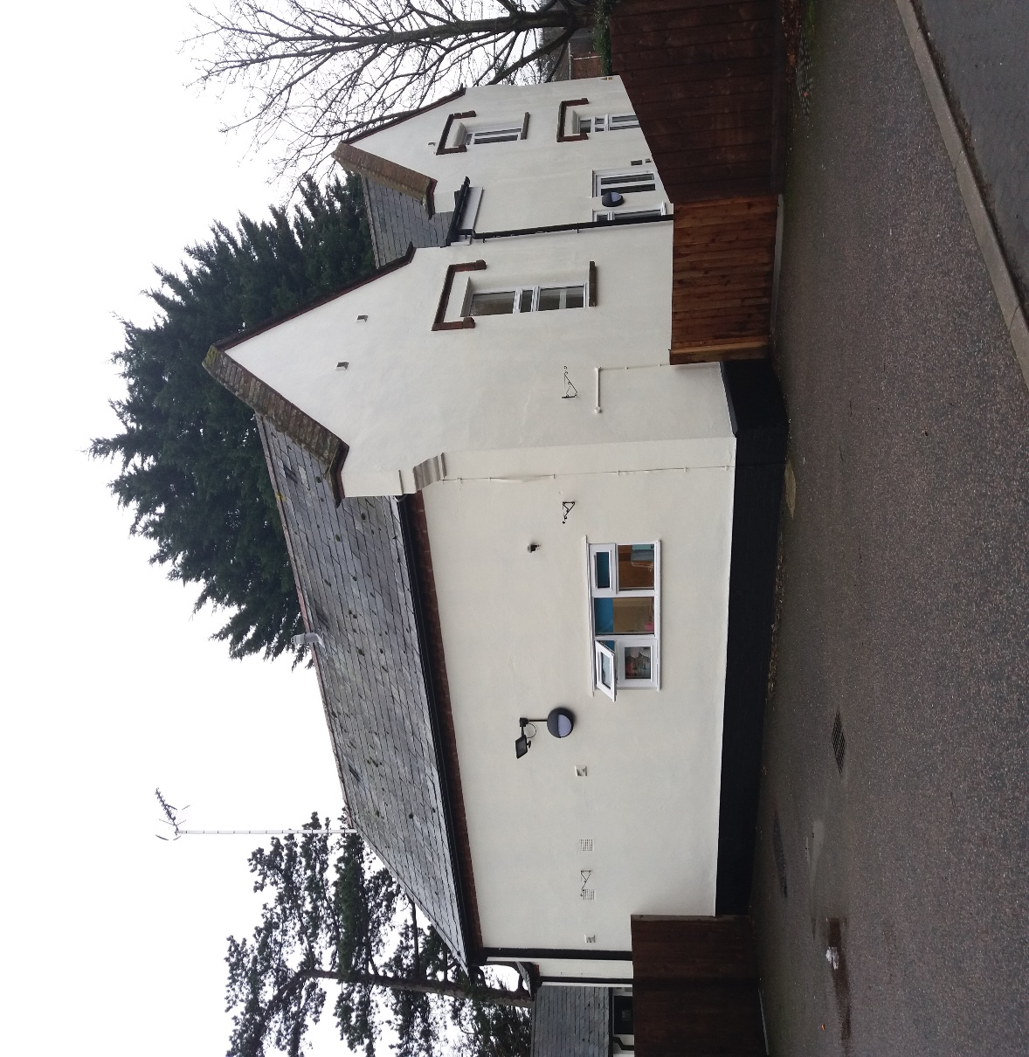

CHILDRENS GUIDE

This Welcome Book was written by a young person who lives at Heather House in a way that she thought would be helpful for other young people moving into the home.

Why did I create this welcome booklet?
I created a welcome book for Heather House because I have personal experience of moving into a new home with new people I don’t know so I understand how scary it can be. This book contains everything you need to know about Heather House including pictures in locations such as London, Felixstowe and the cinema.
Its such a fun and loving place to live.
I really hope you find this pack
helpful
& t helps you to settle in.
- Millie 15yr

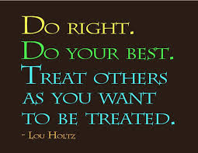
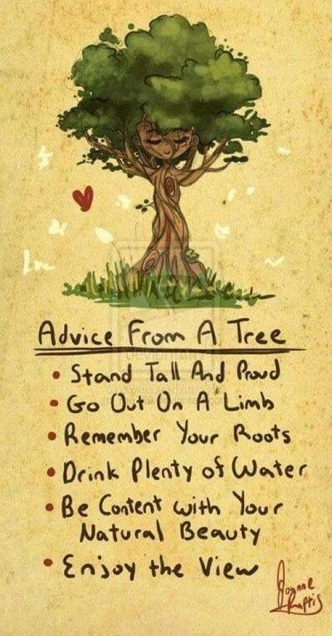

What is the house
like?

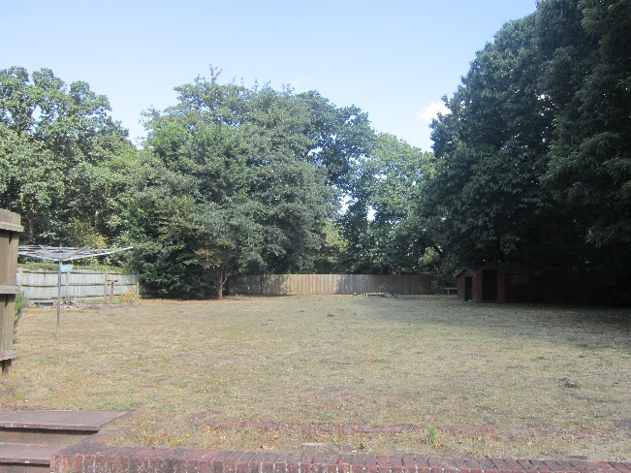
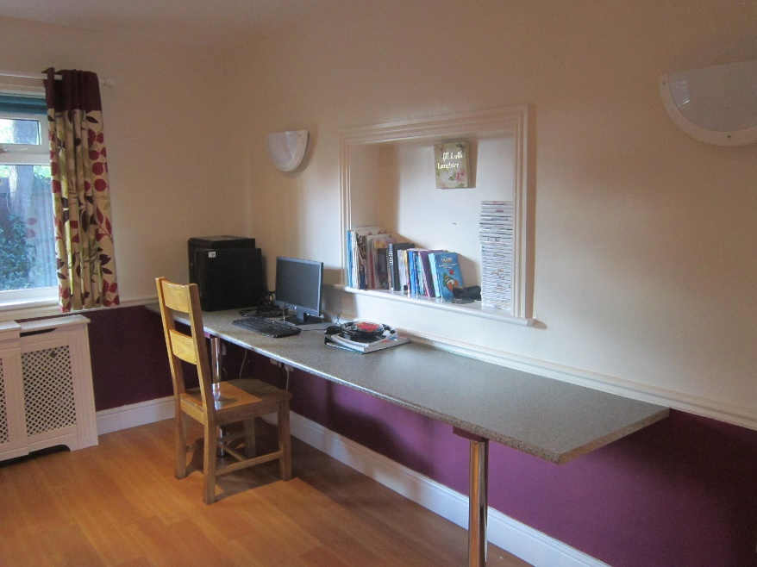
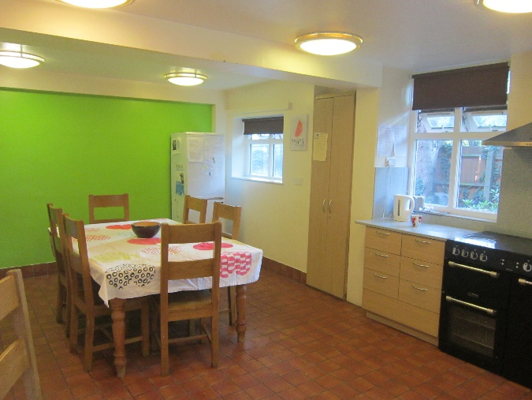
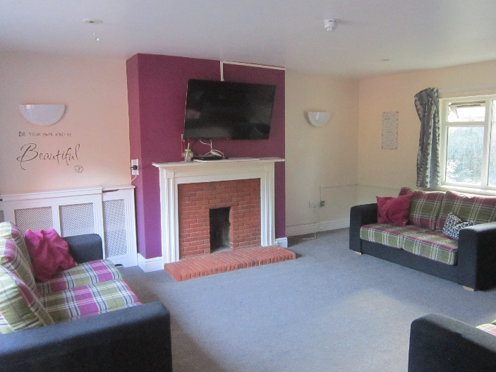
It’s a spacious and homely house with plenty of things to do. It’s a 5 bedroom house with a masssive garden, games room, lounge and kitchen. You will get a chance to visit the home and meet the staff a nd other children before you move in.

Tesco’s, Poundland, NEXT, home bargains, Pets at Home, newsagents, shoe zone and marks and hobby craft are all in walking distance.
What about my first day?

On my first day I was extremely nervous. However, with a lot of encouragement, I overcame my fears. I unpacked and spent time in my room, staff and the other children made me feel welcome, and made me realise that there was nothing to worry about. Your keyworkers will spend time with you, guide and support you through your journey at Heather House.
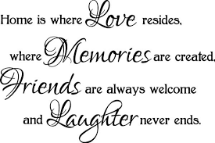

On your first day, the adults will welcome you into the house and show you to your room. They will give you the chance to un-pack your stuff and help you if you wish.
You will get the opportunity to spend time with staff and buy some room accessories of your choice, so you make decorate you room to your own taste. We all have a impact on the weekly menus, the food menus will be rotated weekly for each of the children. An alternative option will be offered if a child does not like a selected meal of another child's choice.

School and getting about…...

School and gaining an education is very important and we will continuously encourage you to go and support you along the way.
We are always here to help with revision, homework, course work or any general concerns you have around your education.

Young people in the house all have an education provision, when you move into Heather House your education shouldn’t change you should still be able to attend the school or the provision you are at. Carers here try to promote you to use public transport to wherever you need to get to, to promote your independence, but you can have lifts to places if needed.

Children’s meetings

Our children's meetings take place every other week. They consist of staff and children coming together and talking about anything that’s on their minds. This is a perfect opportunity for children and adults to discuss any-thing that needs to be brought to their attention.
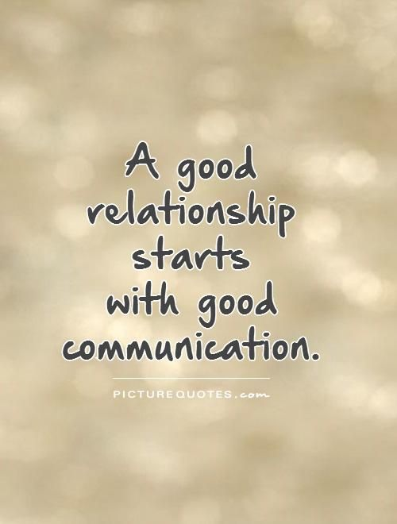
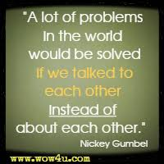
In the past we have talked about holiday plans, Wi-Fi, weekly menu, decorating and general activities we would like to do. We all get time to talk or raise any worries or concerns we have both about in and outside the home.

What would you enjoy doing?
Activities and money

Young people and adults go out and about on activities regularly and take money out with them. The sort of activities we go on are: swimming, bowling, cinema, beach days, theme parks, Felixstowe, trips away and out for dinner to restaurants. We also have i-cards so we can do different activities at sports centres, for example roller skating, badminton and tennis etc...

