Welcome to our home

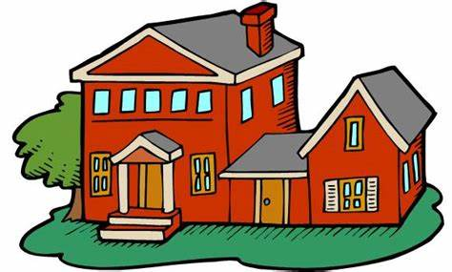

Ashby House Children’s Guide
June 2022
Our Home
Ashby House is a six-bedroom home with two additional bedrooms for staff. Some areas of the home are communal such as the kitchen, lounge, dining room, games room, and Art room.
We have a good-sized garden and are just across the road from the beach. The garden is a good space to hang out with friends and play games.

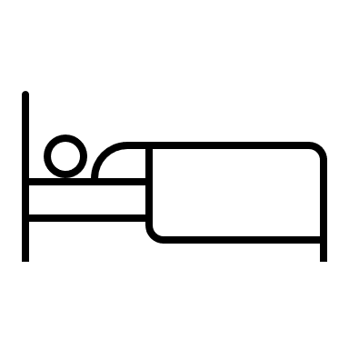
Bedrooms

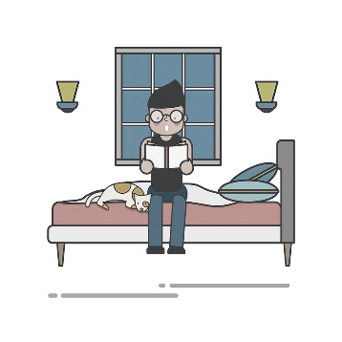
At Ashby House you will have your own Bedroom, you can choose the colour of your room, staff will help decorate it nicely for you. In your room you will find all the furniture you need and places to store your belongings, and a TV.

Your bedroom is your own private space.
You will have a wristband to your room, so you can lock it, only staff can get in. Staff will always knock and wait for an answer before entering, unless they are concerned you are at risk or harm.

Visitors and other young people are not allowed upstairs or in your room; you can spend time with visitors or other young people in the communal areas of the home.

At night you will have an agreed time to settle to your room and will be expected to remain there through the night unless there is an emergency.
It is important to be respectful of the other young people and staff within the home at night and keep noise levels to a minimum.

Communal Areas
In the Lounge we enjoy Movie nights, talking, playing games, watching TV and chilling out. We have Netflix and everyone has their own night to choose what they would like to watch.
In the Dining room we have meals and sometimes spend time getting creative. It’s a lovely light room with a sea view. This room is sometimes used for meetings and can used as a quiet space for studying.
In the Kitchen….
We cook and bake, staff will prepare meals; we will encourage you to help with the cooking and clearing away after meals. We enjoy spending time in here learning new recipes and sharing our creations with everyone.
Everyone is expected to wash their plate and cutlery after every meal.
We all eat our meals together in the dining room.

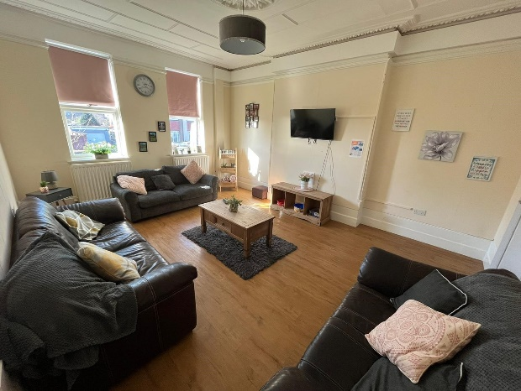

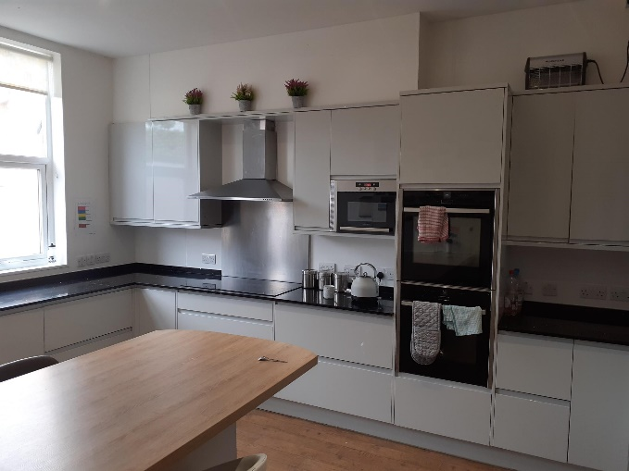
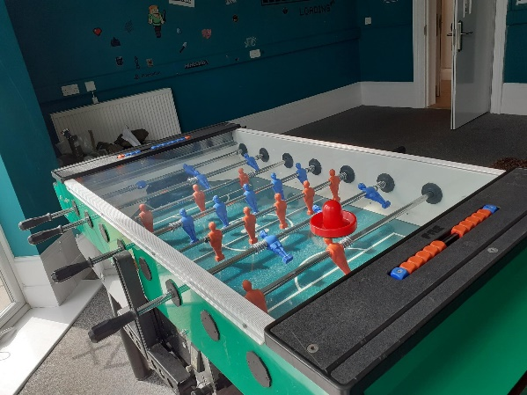
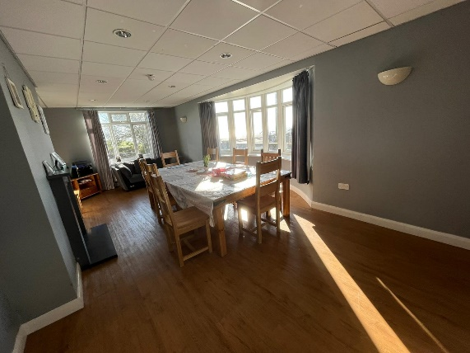
In the Games Room we have table football, a big screen TV, Xbox, board games, DVD’s, and plenty of books.
Seeing/contacting Family and Friends
Staff at Ashby House will always help you to keep in touch with the people that are important to you, like your family or friends.
There is a children’s phone that can be used in the art room to contact family and friends.
You can also have paper, envelopes, and stamps if you would like to send them a letter.

Getting out and about
We have a home’s car that can sometimes be used to drop you off and pick you up if needed when visiting family or friends, if not, staff will give you train or bus fare to meet with family or friends.
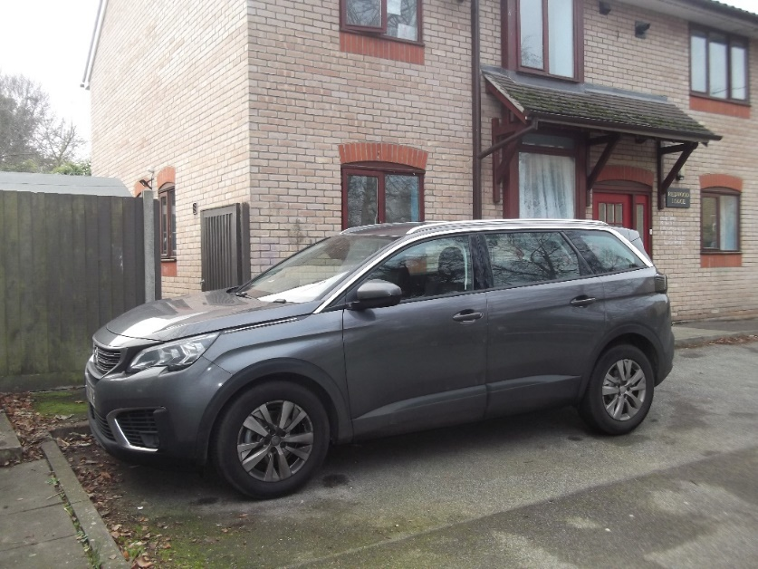

Activities
We like to go out on regular activities some activities we do include: swimming; cinema; fishing; bowling; bike park the zoo and much more.

We will encourage you to share your ideas on activities you would like to do and we especially enjoy celebrating special events and holidays together. Once a year we like to have a holiday.

Clubs Local to Ashby House include-
- Air scouts
- Football clubs
- Martial arts
- Dance schools
- Scouts
- Guides
- Theatre group
Hobbies and interests
We encourage all young people to pursue their hobbies and interests. If you have interests, you would like to explore staff will help you with this and will find a club locally you could join. We feel that attending clubs away from the home will give you opportunity to make new friends locally.

Let’s talk Money!
You will have pocket money each week the amount you receive depends on your age; we ask that you clean your bedroom every Saturday to receive your weekly pocket money.
Age | Pocket Money Amount
11-12 years | £5 per week
13- 15 years | £6 per week
16+ | £8 per week

*You will have the opportunity to earn incentive money, your incentive will be agreed with your key team once you move in.
Mealtimes
Meals at Ashby House are served at around the same time each day, however they can be flexible depending on your day. We enjoy eating together as it gives us all the opportunity to catch up and talk about our day. If you are out seeing family, friends or doing an activity we will save dinner for you. There is a new menu each week you will be asked if you like what is on offer. If you do not there will be an alternative. You will be encouraged to share ideas for the weekly menu. After each meal everyone is expected to wash their own plate and cutlery or put them in the dishwasher - any additional help is always welcomed!
Meals | Mealtimes
Breakfast | 07:00am-09:30am (later at weekends)
Lunch | 12:00-13:30
Dinner | 17:30
Supper | One hour before bedtime
Health
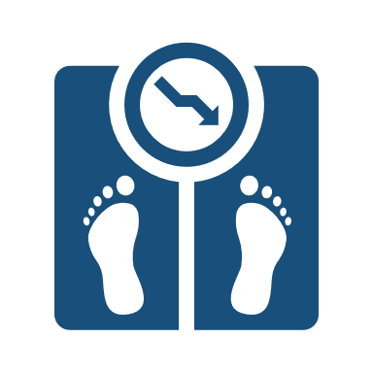
We will help you to be as healthy, happy, and well as you can be. We will encourage healthy eating and living. We do this by providing well balanced meals and opportunities for physical activity. Drugs and Alcohol are not allowed at Ashby House and they will be removed. We will encourage and support any young
person who wants to give up smoking. Staff will also help/ support you with any medical appointments.

Children’s Views & Feelings
Once a month we will ask you about your views and feelings living at Ashby House: during these you and a member of staff will have time to discuss anything that may be on your mind, this time is the perfect opportunity for staff and young people to discuss anything that needs to be brought to the attention of everyone.
Examples of subjects we may cover during this time include: -
- WIFI
- Meals
- Decorating
- Activities
- Achievements
- Behaviour

We also use this time to discuss important subjects such as how people treat each other.

Everyone is given the opportunity to talk if they wish, and raise any worries or concerns, they have either within the home or outside.

Education
At Ashby House we believe that Education is important in giving you the best opportunities for your future. We expect every young person to attend education every day. Your education is important, staff will do their best to help in any way they can whether it is finding the right support for you in school or helping motivate you to get up in the mornings!
We have WIFI to help you do your homework. You can do homework in the dining room, in the kitchen or in your bedroom if you prefer.

Rules at Ashby House
At Ashby House we have general rules and expectations that give us guidance on acceptable and expected behaviours, allowing us to ensure Ashby House is a safe and comfortable environment for all young people and staff. These have all been discussed and agreed by all the young people living in the home based on their wishes of how they want life to be in their home.
Respect is a big part of living at Ashby House: we show respect to all young people, staff, neighbours, and visitors to the home.

- At night we are respectful of others need for rest and keep our noise to a minimum and settle to our rooms with the door closed.
- We are respectful of the home’s properties, damages cost money to repair.
- We take responsibility for cleaning up after ourselves and ensure our personal items are back in our rooms at the end of the day.
- We ensure we behave safely in the home’s car and out in the community.
- We take it in turns to choose things to watch on the homes TV, ensuring everyone has a fair turn.
- To respect others, we only smoke outside of the home in designated smoking areas.
- Everyone has designated laundry days and is expected to do their laundry on these days, staff are always there to help with this.
- All YP’s are respectful of each other’s space and do not go into each other’s bedrooms.

“At Ashby House we treat others as we expect to be treated.”
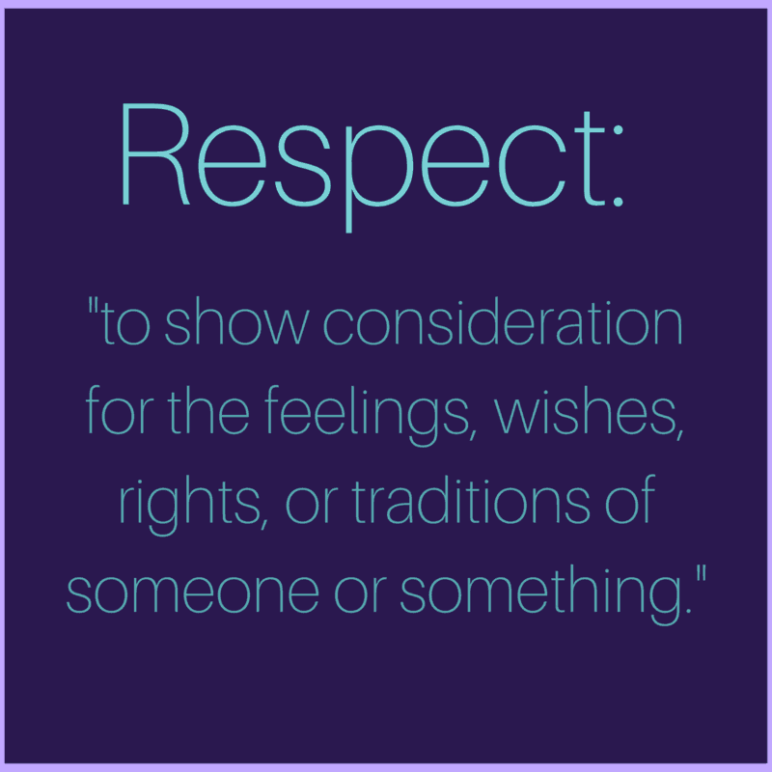

What to do if you are worried, upset or concerned?
We feel it is important you are able share any worries or concerns, we will always try our hardest to help.
you can do so by-
- Talking to us
*Staff are always happy to talk with you, just let us know if you need to have a quite conversation.

- Filling out a “I want you to know form”
*A “I want you to know form” is a way of communicating any concerns, worries or even positive recognition you want management to be aware of, when this has been received by a manager, they will reply back to you ideally within 24hours.

- In “Key work time”
*When you move to the home you will have a “key work team” this team of people will make sure you are happy, safe, and you have everything you need. Each week you will be given the opportunity to have “key work time” this time is for you to spend one to one with your keyworker and gives you opportunity talk about anything you like and address any issues you may have.

- You can also speak with professionals outside of the home such as an independent visitor, advocate and social worker.

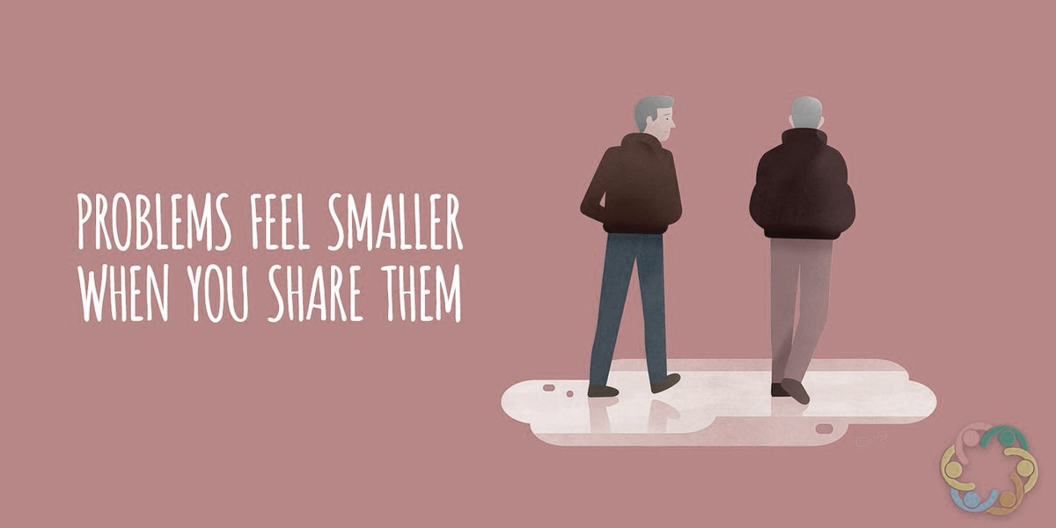

Who visits the home to make sure you are okay?
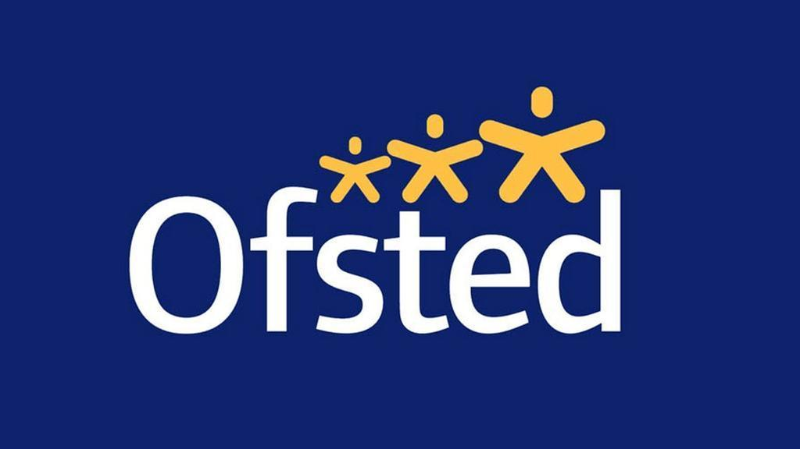
OFSTED Inspectors-
Contact- 08456 404040
OFSTED is government organisation that inspects all children homes to ensure they are run well. You will have the opportunity to speak with them about any worries, concerns or, positives.

Independent Visitors-
An Independent Visitor (IV) is an adult volunteer who befriends and develops a long-term friendship with a young person in care. This can involve helping young people develop new interests, skills and hobbies or going on outings such as to the cinema, bowling or just a walk in the park. You will be offered an “IV” when you are settled at Ashby House.

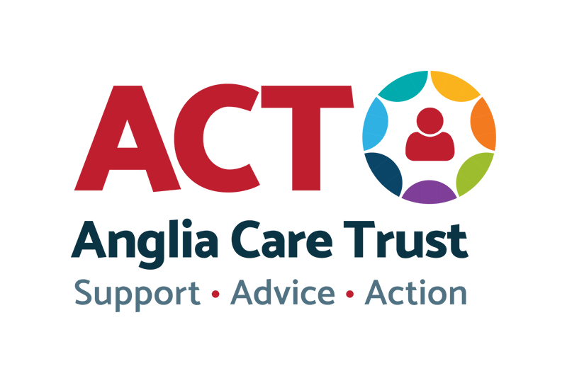
Useful numbers to have-
Children’s rights officer (Julia Ilott)- 0800 917 1119
Turning point for substance misuse-01473 220240
Childline- 0800 1111
Samaritans- 116 123

Other People that may visit the home-
Social workers- You will know your social worker and they will visit you at least every six weeks at home. You will have their contact details, do not worry if you do not as staff will be able to give these to you.
IRO (independent reviewing officer)- You will know who your IRO is, you will normally see these during your CIC reviews (child in care reviews)
CIC nurse (Child in Care nurse)- You will see your CIC nurse at least once a year who will carry out your child in care health review and make sure you are healthy, and well.
Anglia Care Trust (ACT)
Contact- 0800 977 5681
ACT support children and young peoples voices to be heard where they have had a complaint or an issue to resolve about their care. ACT will visit the home occasionally and spend time with all the Young People.

Meet the Ashby House Team
ments here.

